From its national debut at Coverings 2019, Anthology tile has become a force to be reckoned with in the industry. With award-winning designs and some of the most innovative products in the category, Anthology is back with great new collections at Coverings 2021 to show why the distributors and dealers across the country are in love with the brand.

Anthology creates decorative mosaics, trims, piece and floor tiles all available in stone, glass, ceramic and porcelain. Designed locally and sourced globally, Anthology provides to the market stylish and innovative products.
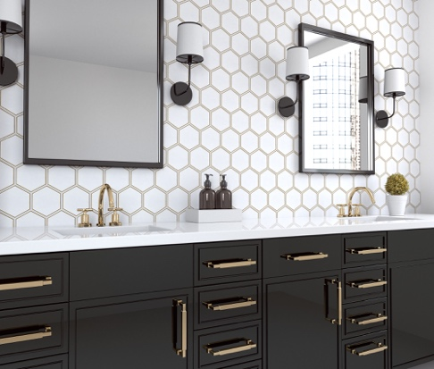
Our commitment allows our clients to join us in the power of purchase, leaving them with not only an abundance of products to choose from but guaranteed great margins.

Anthology’s distributors can make Informed decisions using our technology and data driven approach to the market.

We offer stocking programs tailored to your customer's tastes, to keep you competitive in your market. Have a client that needs something specific? No problem. Anthology's global sourcing team can source anything to support your clients’ needs in a wide range of applications. And you can take advantage of our buying power.

Our facilities across the country and throughout the world are stocked with inventory and can service all customers nationwide. With a commitment to ship all orders within 24-72 hours our unparalleled logistics team is standing by to serve you.

We welcome you in joining the Anthology family.

Anthology Tile brings American made style and a whole lot more back to life at Coverings 2021

The 30” x 30” booth (# 3048) will be the launching platform for collections like:

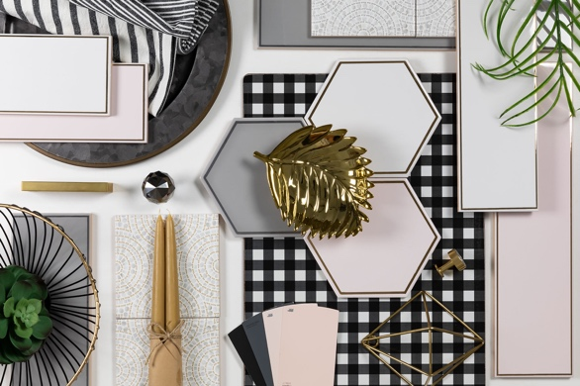
On the Edge
Classic meets glamour is the only way to describe our On the Edge collection. A timeless palette of white, blush, and gray ceramic framed with real gold, platinum and rose gold metals. These beautiful creations were inspired by trending shapes elevated with metallic accents, adding the jewelry as a perfect design accessory. Simple elegance and designer patterns, take your next project to the edge with this fashion-forward ceramic.

The company is also launching its first Made in the USA collection.

Captiva Island
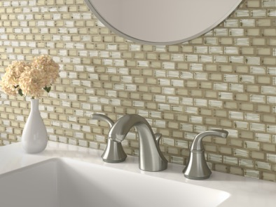
Handcrafted and made in the U.S. Anthology’s exclusive collection, Captiva Island is designed to create stylish spaces for all environments. This glass tile simply glistens in water, reflecting sunlight, and creating a coastal atmosphere even when miles away from the ocean. The glass chips are full of character and shimmer in transparent colors and rich jewel tones. These glass mosaics create endless possibilities for transforming contemporary, transitional and traditional spaces. There is exceptional quality with unmatched brilliance and mesmerizing beauty, infinite custom design options, limited only by one’s imagination.

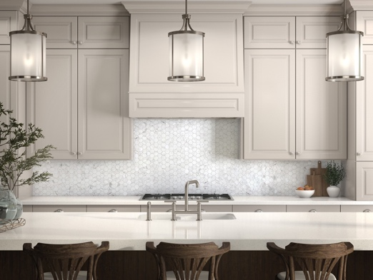
Fabrique & Nature
These incredible stone look mosaics made of recycled glass are hyper realistic in 8 unique different patterns. Capture that classic, timeless look of real Cararra marble without the maintenance of traditional stone. Bring nature indoors with eye catching and functional mosaics that will create your next designer masterpiece.

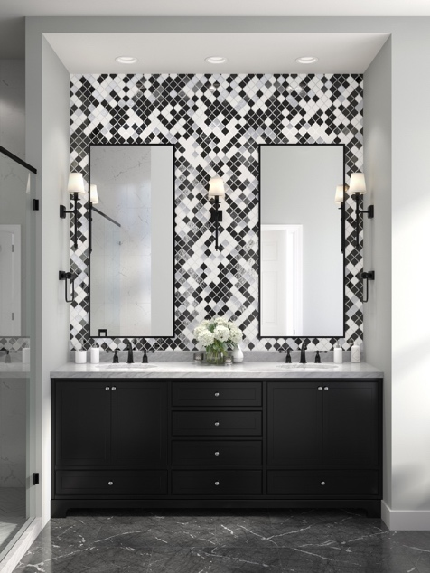

Chíc
Our Chic collection blends together 8mm glass and stone in rich and luxurious marble shapes and coordinating metallic textured glass. The 6, truly radiant designs come in an array of classically colored combinations. Arabesque shapes and elegant penny rounds, elevate your space with these dramatic mosaics.

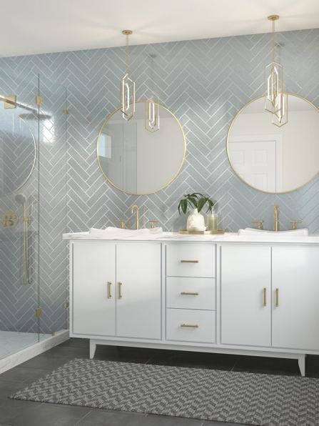

Metro Brix
Classic brick shape in 4 elegant colors, these subway tiles can be used for a multitude of applications. Fired at high temperatures, clay brick tiles are reliably solid, long-lasting, low-maintenance and can be easily installed indoors and out. In classic colors, these extruded clay designs enable you to create industrial, rustic farmhouse, or modern classic designs or capture a totally unique new look with our Metro Brix.

To learn more, request material, or schedule interviews with our head designer, please contact Anthology’s Marketing Manager, Karla Soto at ksoto@surfaces.net or (305) 372 9787 Ext. 150

